**PRACTICAL NO:-10**

**a. Create a web application to demonstrate JS Bootstrap Button.**

TO add bootstrap libraries you have to to first load all he required libraries of bootstrap in current project.

You have to follow below steps to load all libraries:

First you have to choose the add new item and In you have to add client-side library.

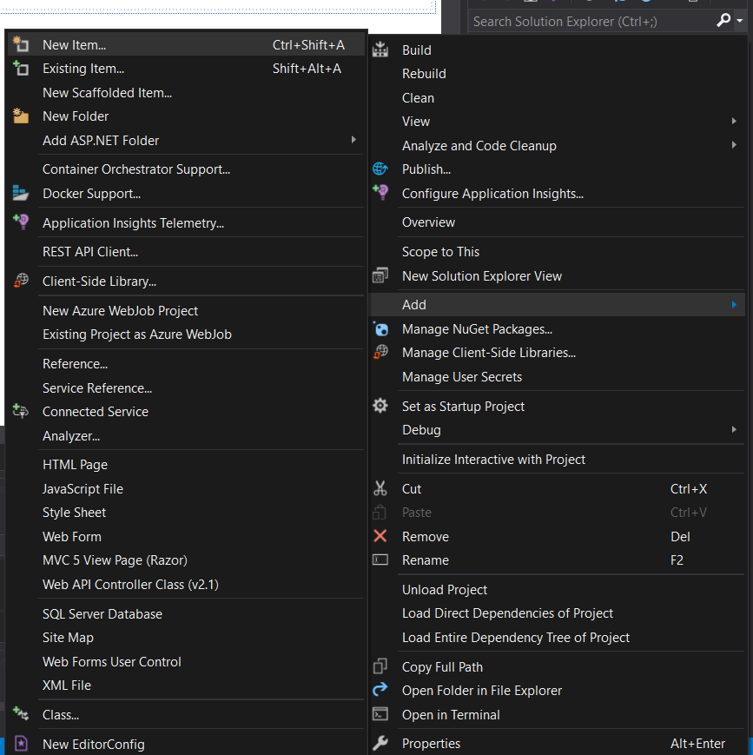

Then you have to search for bootstrap here:

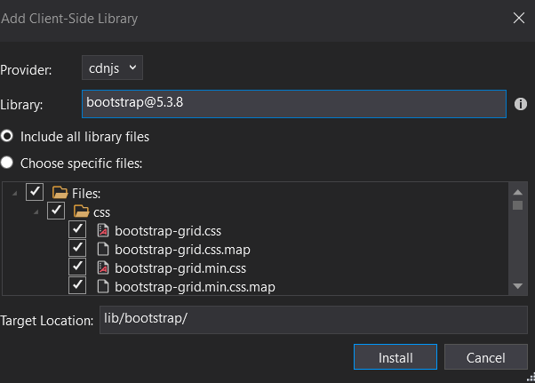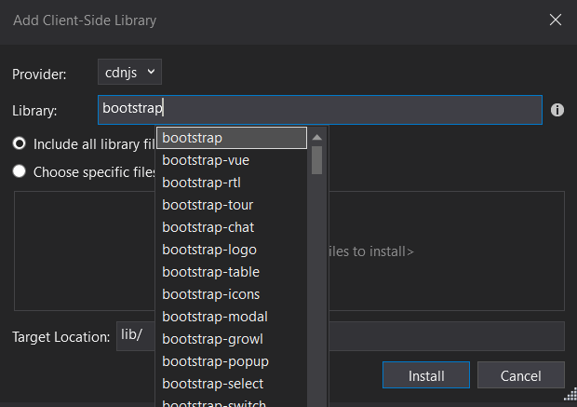

Then you can install it.

Then you can see that all libraries are available in lib folder.

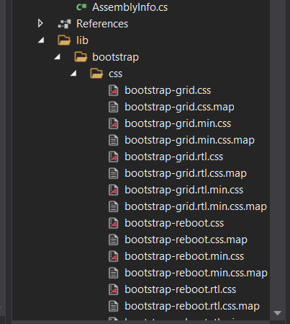

Now just search for js folder and drag and drop the jquery.js file into your working file.

For different bootstrap operation you have to first drag and drop below file in your project.



This will provide you all the required classes for using them.

Now you can easily able to access these properties.

**CODE:-**

<%@ Page Language="C#" AutoEventWireup="true" CodeBehind="a10.aspx.cs" Inherits="prac10.a10" %>

<!DOCTYPE html>

<script src="lib/bootstrap/jquery.js"></script>

<html xmlns="http://www.w3.org/1999/xhtml">

<head runat="server">

<title></title>

</head>

<body>

<form id="form1" runat="server">

<div>

</div>

<asp:Label ID="Label1" runat="server" Text="Label"></asp:Label>

<p>

<asp:Button ID="Button1" runat="server" style="z-index: 1; left: 273px; top: 96px; position: absolute" Text="hide text" />

</p>

<script type="text/javascript">

$(document).ready(

function () {

$("#Label1").text("This is done through Ajax control");

$("#Button1").hover( //when button clicked it goes to server and the hide method or anything will not works..

function ()

{

$(this).hide();

$("#Label1").hide();

}

);

}

);

</script>

<asp:Label ID="Label2" runat="server" style="z-index: 1; left: 13px; top: 99px; position: absolute; width: 253px" Text="hover button to hide above text"></asp:Label>

<p>different types of buttons are as follow:-</p>

<p>

<link href="lib/bootstrap/css/bootstrap.min.css" rel="stylesheet" />

&nbsp;</p>

<asp:Button ID="Button3" runat="server" Text="Button-primmry" class="btn btn-primary " />

<asp:Button ID="Button4" runat="server" Text="Button-secondary" class="btn btn-secondary " />

<asp:Button ID="Button5" runat="server" Text="Button success" class="btn btn-success " />

<asp:Button ID="Button6" runat="server" Text="Button-danger" class="btn btn-danger " />

<asp:Button ID="Button7" runat="server" Text="Button-warning" class="btn btn-warning " />

<asp:Button ID="Button8" runat="server" Text="Button-info" class="btn btn-info" />

<asp:Button ID="Button9" runat="server" Text="Button-dark" class="btn btn-dark " OnClick="Button9_Click" />

<asp:Button ID="Button2" runat="server" Text="Button-light" class="btn btn-light " />

<asp:Button ID="Button10" runat="server" Text="Button-link" class="btn btn-link " />

<p>

&nbsp;</p>

<p>

&nbsp;</p>

</form>

</body>

</html>

**OUTPUT:-**

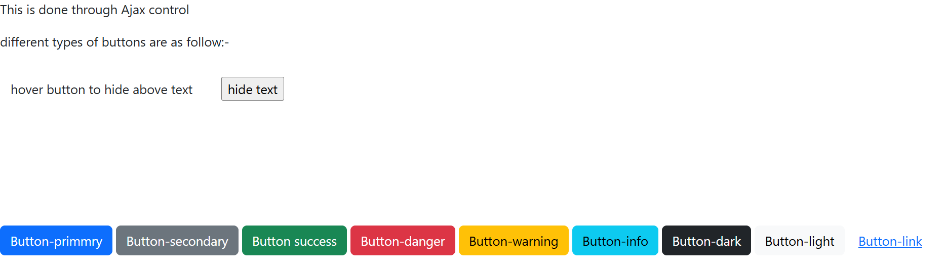

When you hover on button:-

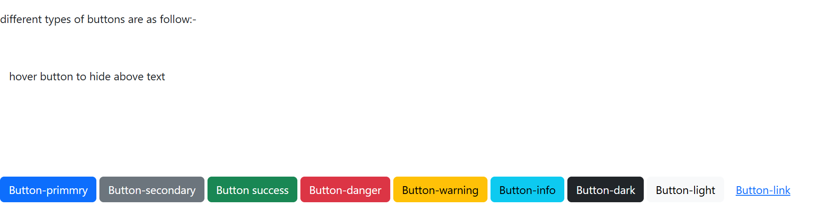

**CODE:-**

<p>

<link href="lib/bootstrap/css/bootstrap.min.css" rel="stylesheet" />

&nbsp;</p>

<asp:Button ID="Button3" runat="server" Text="Button-primmry" class="btn btn-primary " />

<asp:Button ID="Button4" runat="server" Text="Button-secondary" class="btn btn-secondary " />

<asp:Button ID="Button5" runat="server" Text="Button success" class="btn btn-success " />

<asp:Button ID="Button6" runat="server" Text="Button-danger" class="btn btn-danger " />

<asp:Button ID="Button7" runat="server" Text="Button-warning" class="btn btn-warning " />

<asp:Button ID="Button8" runat="server" Text="Button-info" class="btn btn-info" />

<asp:Button ID="Button9" runat="server" Text="Button-dark" class="btn btn-dark " OnClick="Button9_Click" />

<asp:Button ID="Button2" runat="server" Text="Button-light" class="btn btn-light " />

<asp:Button ID="Button10" runat="server" Text="Button-link" class="btn btn-link " />

<p>

&nbsp;</p>

<p>

**Js-bootstrap buttons are as follow:-**



**b. Create a web application to demonstrate use of various Ajax controls.**

**First you have to add**

**1)script manager**

**2)updatePanel**

**3)updategprogess**

**4)Timer:- in update panel**

It is required to add into a form.

Now you have to add the content into updatepanel that you want to update.

**You can set timer of time as below:**

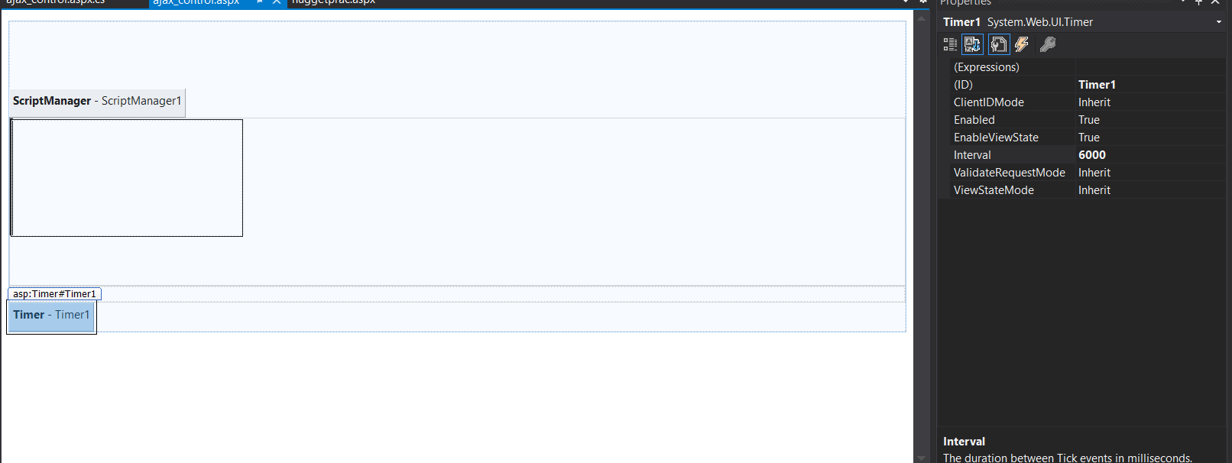

**Now you can write code in page_load event to execute after specified interval.**

**To access div through .cs files you have to run them at server**

**Means you have set runat=”server” property as well as have to defined the id to access them.**

To execute anything between update progess you have to defined it in updateProgress.

HTML CODE:-

<%@ Page Language="C#" AutoEventWireup="true" CodeBehind="ajax_control.aspx.cs" Inherits="Nuggetpackage.ajax_control" %>

<!DOCTYPE html>

<html xmlns="http://www.w3.org/1999/xhtml">

<head runat="server">

<title></title>

<style>

.myDiv1 {

border: 2px solid black;

width: 0px;

background-color: darkred;

height: 150px;

text-align: center;

}

.myDiv2 {

border: 2px solid black;

width: 300px;

height: 150px;

text-align: center;

}

.auto-style1 {

width: 200px;

height: 200px;

}

</style>

</head>

<body>

<form id="form1" runat="server">

<br />

<br />

<br />

<asp:ScriptManager ID="ScriptManager1" runat="server"></asp:ScriptManager>

<asp:UpdatePanel ID="UpdatePanel1" runat="server">

<ContentTemplate>

<br />

<br />

<br />

<div class="myDiv2" id="div2" runat="server"> <!--assign id and runat server so that able to change them when execution through cs -->

<div class="myDiv1" id="div1" runat="server" >

</div>

</div>

<br />

<br />

<asp:Timer ID="Timer2" runat="server" Interval="2000">

</asp:Timer>

</ContentTemplate>

</asp:UpdatePanel>

<asp:UpdateProgress ID="UpdateProgress1" runat="server">

<ProgressTemplate>

<img alt="loading" class="auto-style1" src="update%20gif.gif" />

</ProgressTemplate>

</asp:UpdateProgress>

</form>

</body>

</html>

**CS CODE:-**

using System;

using System.Collections.Generic;

using System.Linq;

using System.Web;

using System.Web.UI;

using System.Web.UI.WebControls;

using System.Threading;

namespace Nuggetpackage

{

public partial class ajax_control : System.Web.UI.Page

{

protected void Page_Load(object sender, EventArgs e) //don’t try while block iykyk

{

if (Session["a"] == null)

{

int a = 30;

Session["a"] = a;

}

else

{

if ( Convert.ToInt32( Session["a"]) < 300)

{

int a = Convert.ToInt32(Session["a"].ToString()) + 30;

Session["a"] = a;

div1.Style["Width"] = Convert.ToString(a) + "px";

Thread.Sleep(1000); //to execute updateprogess sleep is used ..is in System.Threading

}

}

}

}

}

**OUTPUT:-**

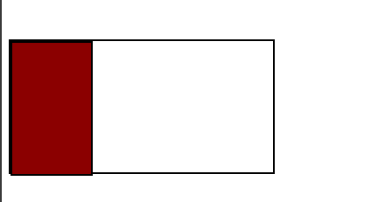

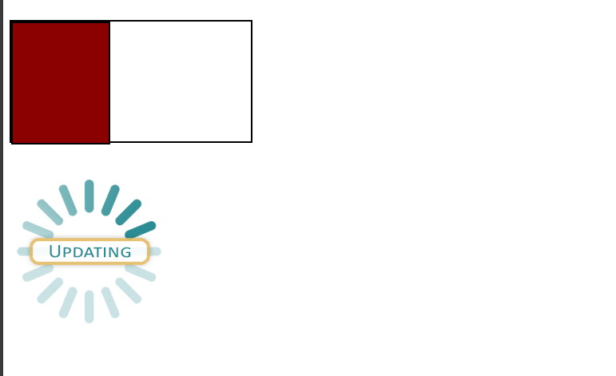

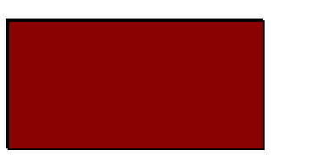

**c. Create a web application to demonstrate Installation and use of NuGet package.**

To install right click on your project in solution explorer.

You will get following window:-

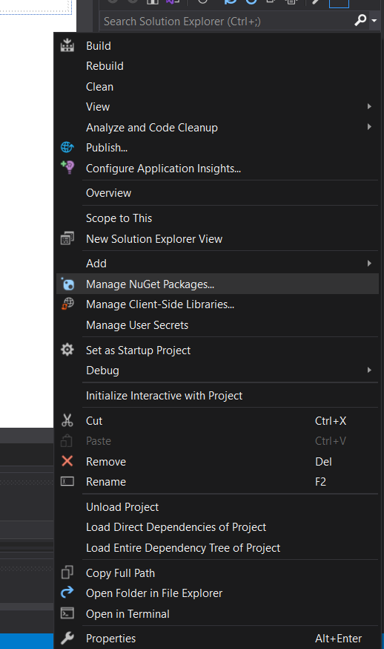

Now search for bootstrap and jquery and install them.

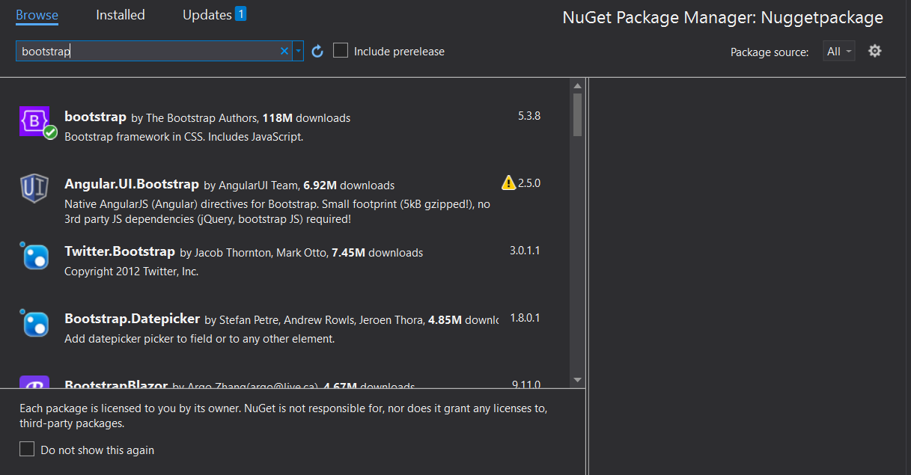

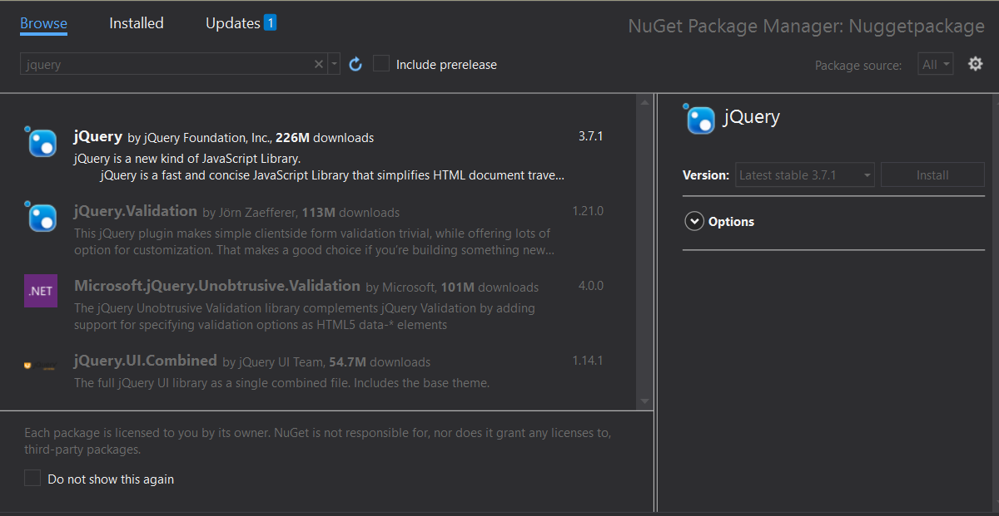

Now all the packages are available in in solution explorer in **Refernces.**

**Now you can easily use them by drag drop frm there.**

Now you can use them directly in code:

**CODE:-**

<%@ Page Language="C#" AutoEventWireup="true" CodeBehind="nuggetprac.aspx.cs" Inherits="Nuggetpackage.nuggetprac" %>

<!DOCTYPE html>

<script src="Scripts/jquery-3.7.1.min.js"></script>

<html xmlns="http://www.w3.org/1999/xhtml">

<head runat="server">

<title></title>

</head>

<body>

<form id="form1" runat="server">

<div>

<a href="#">you can't click me</a>

<script type="text/javascript">

$(document).ready(

function () {

$("a").css("color", "red")

.css("font-size", "20px")

.css("text-align", "center");

}

);

$("a").mouseover(

function () {

$(this).hide();

}

)

$("a").mouseout(

function () {

$(this).show();

}

)

</script>

</div>

</form>

</body>

</html>

**OUTPUT:-**



